SERVICENOW PROJECT
Implement Client Script & UI Policy (Incident)
Complete Project Documentation (Phases 1 – 6)
Date
Team ID
Project Name | Implement Client Script & UI Policy (Incident)
Maximum Marks

Contents
Phase | Title
Phase 1 | Ideation Phase
Phase 2 | Requirement Analysis
Phase 3 | Project Design Phase
Phase 4 | Project Planning Phase
Phase 5 | Project Development & Testing Phase
Phase 6 | Project Documentation (Project Report)

PHASE 1 – IDEATION PHASE
Implement Client Script & UI Policy (Incident)
Date | [Enter date]
Team ID
Project Name | Implement Client Script & UI Policy (Incident)
Maximum Marks | 10 Marks (Idea Identification & Prioritization: 4 | Define the Problem Statements: 2 | Empathize & Discover: 4)

Contents of this Ideation Phase document
Part | Section | Marks
1 | Idea Identification & Prioritization | 4 Marks
2 | Define the Problem Statements | 2 Marks
3 | Empathize & Discover | 4 Marks

Part 1: Idea Identification & Prioritization
Step 1: Team Collaboration and Problem Selection
The team analyzed the Incident Management lifecycle from the perspectives of Service Desk Agents, Assignment Group Members, Incident Managers, and ServiceNow Administrators. During project discussions, several challenges related to Incident data quality, validation, routing accuracy, and user guidance were identified.
The team observed that Incident records are often submitted with incomplete or inconsistent information. Critical fields such as Assignment Group and Assigned To may be left blank, while important values like Urgency and State may be modified incorrectly. These issues can lead to delays in incident assignment, inaccurate reporting, SLA violations, and additional manual effort.
To address these challenges, the team selected a solution that uses ServiceNow UI Policies and Client Scripts to dynamically control field behavior, validate records, provide user guidance, and improve Incident data quality.
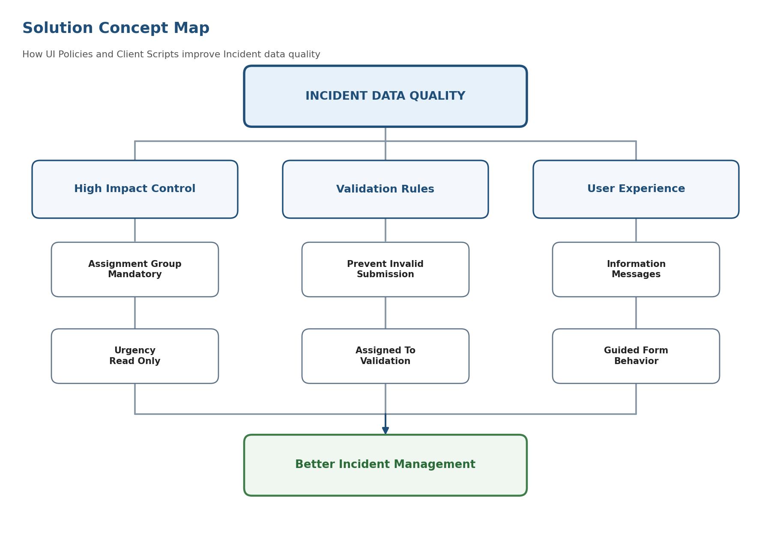
Figure 1 – Solution Concept Map
Step 2: Idea Identification and Grouping
ID | Idea | Example Detail | Group
I1 | High Impact Control | Impact = High makes Assignment Group mandatory and Urgency read-only | Dynamic Control
I2 | Contextual Guidance | Show messages explaining required actions | User Experience
I3 | Assignment Validation | Validate Assigned To and Assignment Group details | Data Quality
I4 | Submission Guard | Stop incomplete high-impact incidents before saving | Validation
I5 | State Protection | Restrict unauthorized State modifications | Governance
I6 | Context Visibility | Display controls only when required | Usability
I7 | Change Detection | Re-evaluate rules when Impact changes | Automation
I8 | Rule Separation | Separate UI behavior and validation logic | Maintainability

The identified ideas were categorized into Dynamic Control, User Experience, Data Quality, Validation, Governance, Automation, and Maintainability. This helped the team evaluate which ideas would provide the greatest business value and operational improvement.
Step 3: Idea Prioritization
Idea | User Value | Feasibility | Control Strength | Role
High Impact Control | High | High | High | Core
Submission Guard | High | High | High | Core
Change Detection | High | Medium | High | Core
Rule Separation | High | Medium | High | Foundation
Contextual Guidance | High | High | Medium | Enhancement
Assignment Validation | Medium | Medium | High | Enhancement
State Protection | Medium | Medium | High | Enhancement
Context Visibility | Medium | High | Medium | Enhancement

After evaluation, the team selected High Impact Control, Submission Guard, Change Detection, and Rule Separation as the core solution components because they directly improve Incident quality, reduce manual errors, and strengthen ServiceNow Incident Management processes.
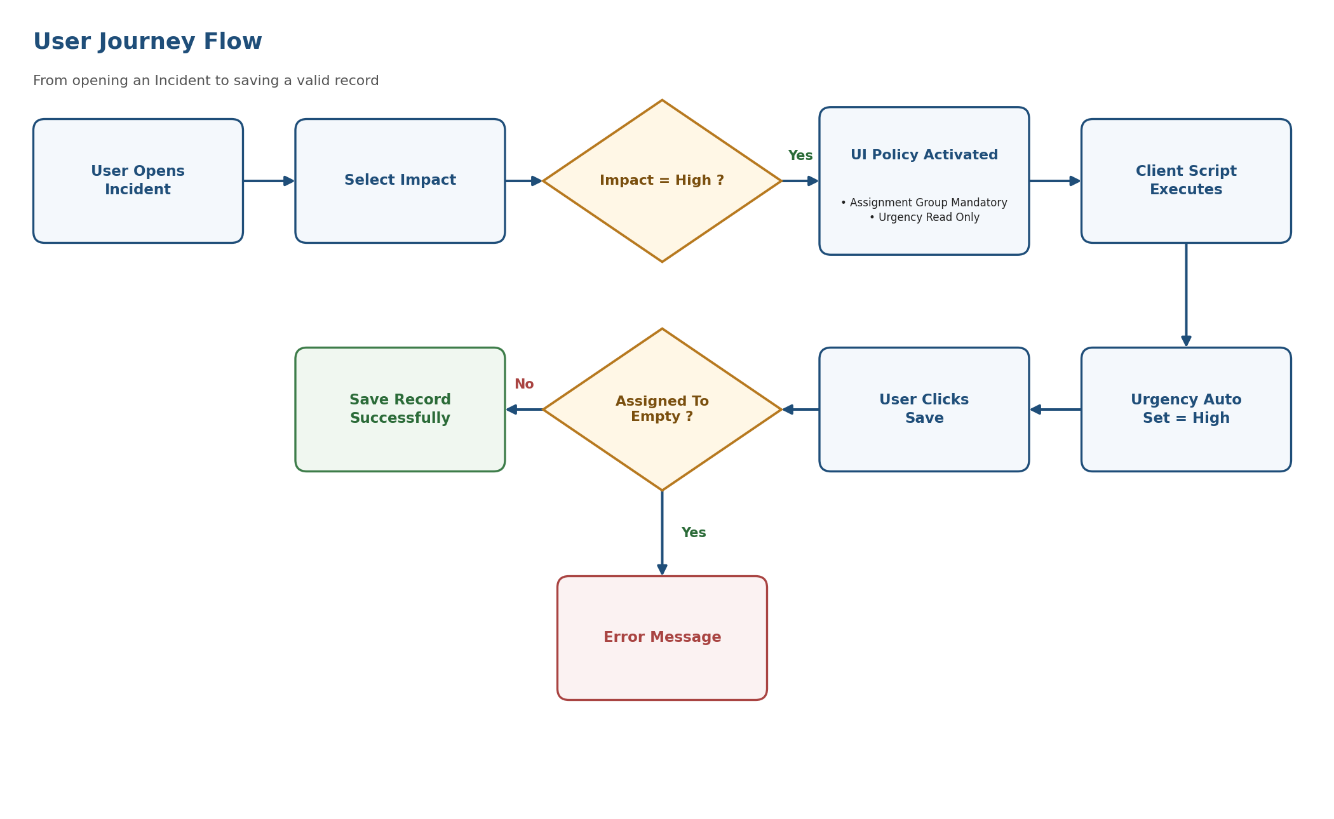
Figure 2 – User Journey Flow
Part 2: Define the Problem Statements
Customer Problem Statement
Organizations rely on Incident records to manage service disruptions and track issue resolution. However, users frequently create Incident records with incomplete, inconsistent, or incorrect information.
Important fields such as Assignment Group and Assigned To may be left blank, resulting in delays in incident routing and escalation. Critical fields like Urgency and State may also be modified incorrectly, reducing data accuracy and affecting reporting quality.
Manual validation alone is insufficient to ensure consistent Incident data quality. As a result, organizations experience delayed resolutions, increased administrative effort, poor reporting accuracy, and potential SLA violations.
Therefore, there is a need for a solution that automatically validates Incident information, dynamically controls field behavior, prevents invalid submissions, and ensures consistent Incident management processes.
User Perspective Analysis
Persona | Goal | Challenge | Feeling
Service Desk Agent | Create complete Incidents quickly | Mandatory fields change based on context | Uncertain and slower
Assignment Group Member | Receive properly routed Incidents | Missing assignment information | Frustrated
Incident Manager | Maintain high-quality Incident records | Incorrect value modifications | Concerned
ServiceNow Administrator | Maintain business rules efficiently | Mixed validation and UI logic | Burdened

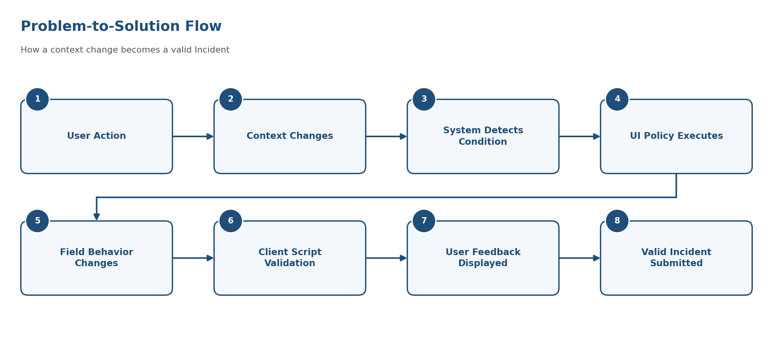
Figure 3 – Problem-to-Solution Flow
Core Problem Statement
Service desk users need a context-aware Incident form that automatically applies the correct field behavior when an Incident becomes high impact, validates critical information before submission, and prevents inappropriate edits without requiring users to memorize every business rule.
Objective
The objective of this project is to use ServiceNow UI Policies and Client Scripts to improve Incident data quality by:
- Making fields mandatory based on business conditions.
- Automatically updating field values.
- Restricting unauthorized modifications.
- Preventing invalid record submissions.
- Improving user experience.
- Enhancing data consistency.
- Supporting SLA compliance.
Part 3: Empathize & Discover
Primary Persona
Service Desk Agent responsible for creating, assigning, updating, and managing Incident records during normal support operations and high-impact service disruptions.
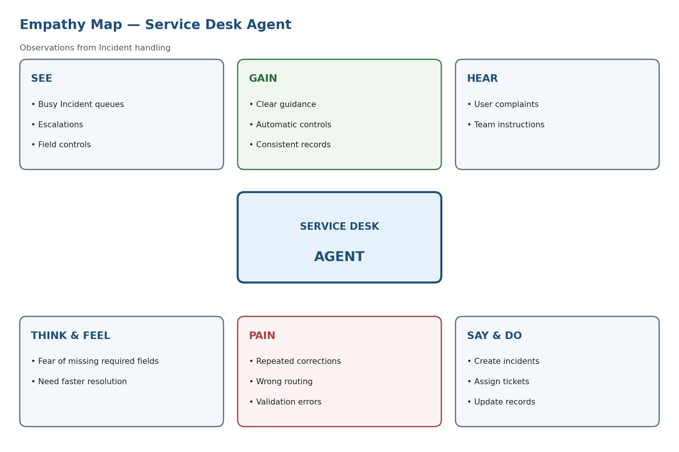
Figure 4 – Empathy Map
Empathy Analysis
Area | Observation
SEE | Busy Incident queues, changing priorities, escalation information
HEAR | User complaints, escalation requests, management instructions
THINK & FEEL | Concerned about missing important fields and making mistakes
SAY & DO | Creates, updates, assigns, and submits Incident records
PAIN | Repeated corrections, unclear rules, routing uncertainty
GAIN | Clear guidance, automatic validation, faster processing

Pain-to-Design Mapping
User Pain | Design Response | ServiceNow Mechanism
Unclear mandatory fields | Display requirements dynamically | UI Policy (Mandatory Action)
Accidental edits | Protect sensitive fields | UI Policy (Read-only Action)
Late error discovery | Validate before save | Client Script (onSubmit)
Repeated corrections | Auto-check dependent values | Client Script (onChange)
High-impact pressure | Trigger controls automatically | Condition: Impact = High
Confusing behavior | Display user feedback messages | g_form Messages

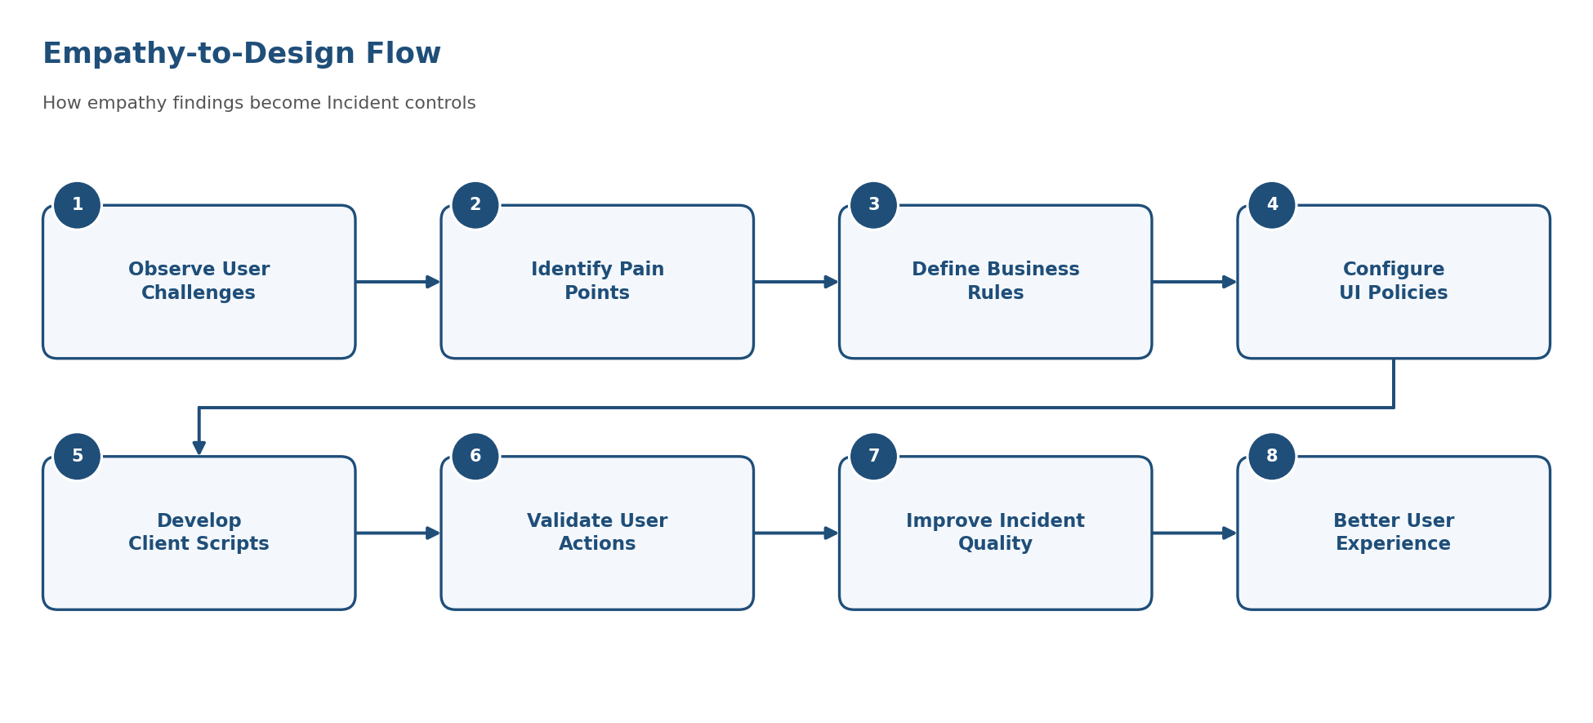
Figure 5 – Empathy-to-Design Flow
Expected Benefits
- Improved Incident data accuracy.
- Faster Incident assignment and routing.
- Better SLA compliance.
- Reduced manual corrections.
- Improved reporting quality.
- Enhanced user experience.
- Better governance and control of Incident records.
Conclusion
The ideation phase identified the key challenges associated with Incident data quality and user experience within ServiceNow Incident Management. By analyzing user needs, defining the problem, prioritizing solution ideas, and mapping user pain points to ServiceNow capabilities, the team developed a practical solution based on UI Policies and Client Scripts. This solution provides dynamic controls, automated validation, user guidance, and improved governance, ensuring more accurate, reliable, and efficient Incident management.

PHASE 2 – REQUIREMENT ANALYSIS
Implement Client Script & UI Policy (Incident)
Date
Team ID
Project Name | Implement Client Script & UI Policy (Incident)
Maximum Marks | 4 Marks

1. Customer Journey / User Experience
The customer journey is mapped for the ServiceNow Incident scenario, covering each step, the user's interaction, the experience, the pain point and the opportunity.
Step | Interaction | User Experience | Problem / Pain Point | Opportunity
Open Incident | Agent opens Incident form | Agent begins entering Incident information | Multiple fields may require attention | Provide a clear structured form
Select Impact | Agent selects Impact | System identifies Incident impact | Agent may forget rules associated with High Impact | Automatically detect Impact
Apply Rules | UI Policy changes fields | Assignment Group becomes mandatory and Urgency becomes read-only | Manual checking can cause mistakes | Automate field behaviour
Enter Assignment Group | Agent selects group | Required field is completed | Agent may try to submit without group | Show mandatory indicator
Submit Incident | Client Script validates form | System checks required information | Missing information can cause incomplete records | Block invalid submission
Confirmation | Incident is submitted | Agent receives a successfully created Incident | Incorrect data can affect later processing | Ensure validation before submission
After Submission | Support team handles Incident | Correct group receives the Incident | Poor initial data can cause delays | Improve Incident quality

2. Requirement Flow
The requirement analysis flow shows how the Service Desk Agent's actions lead to dynamic field control and validated submission.
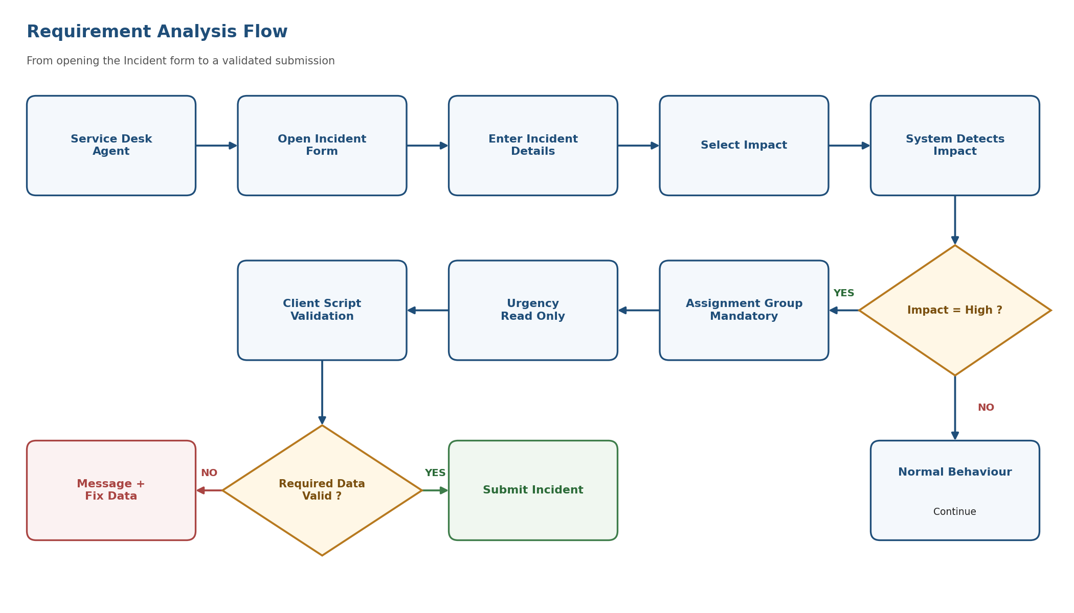
Figure 6 – Requirement Analysis Flow
3. Data Flow Requirement
A Data Flow Diagram shows how data enters and leaves the system, what changes the information, and where data is stored. For this project, data moves from the Service Desk Agent through the Incident form, UI Policy and Client Script, and validation, and is finally stored in the ServiceNow database.
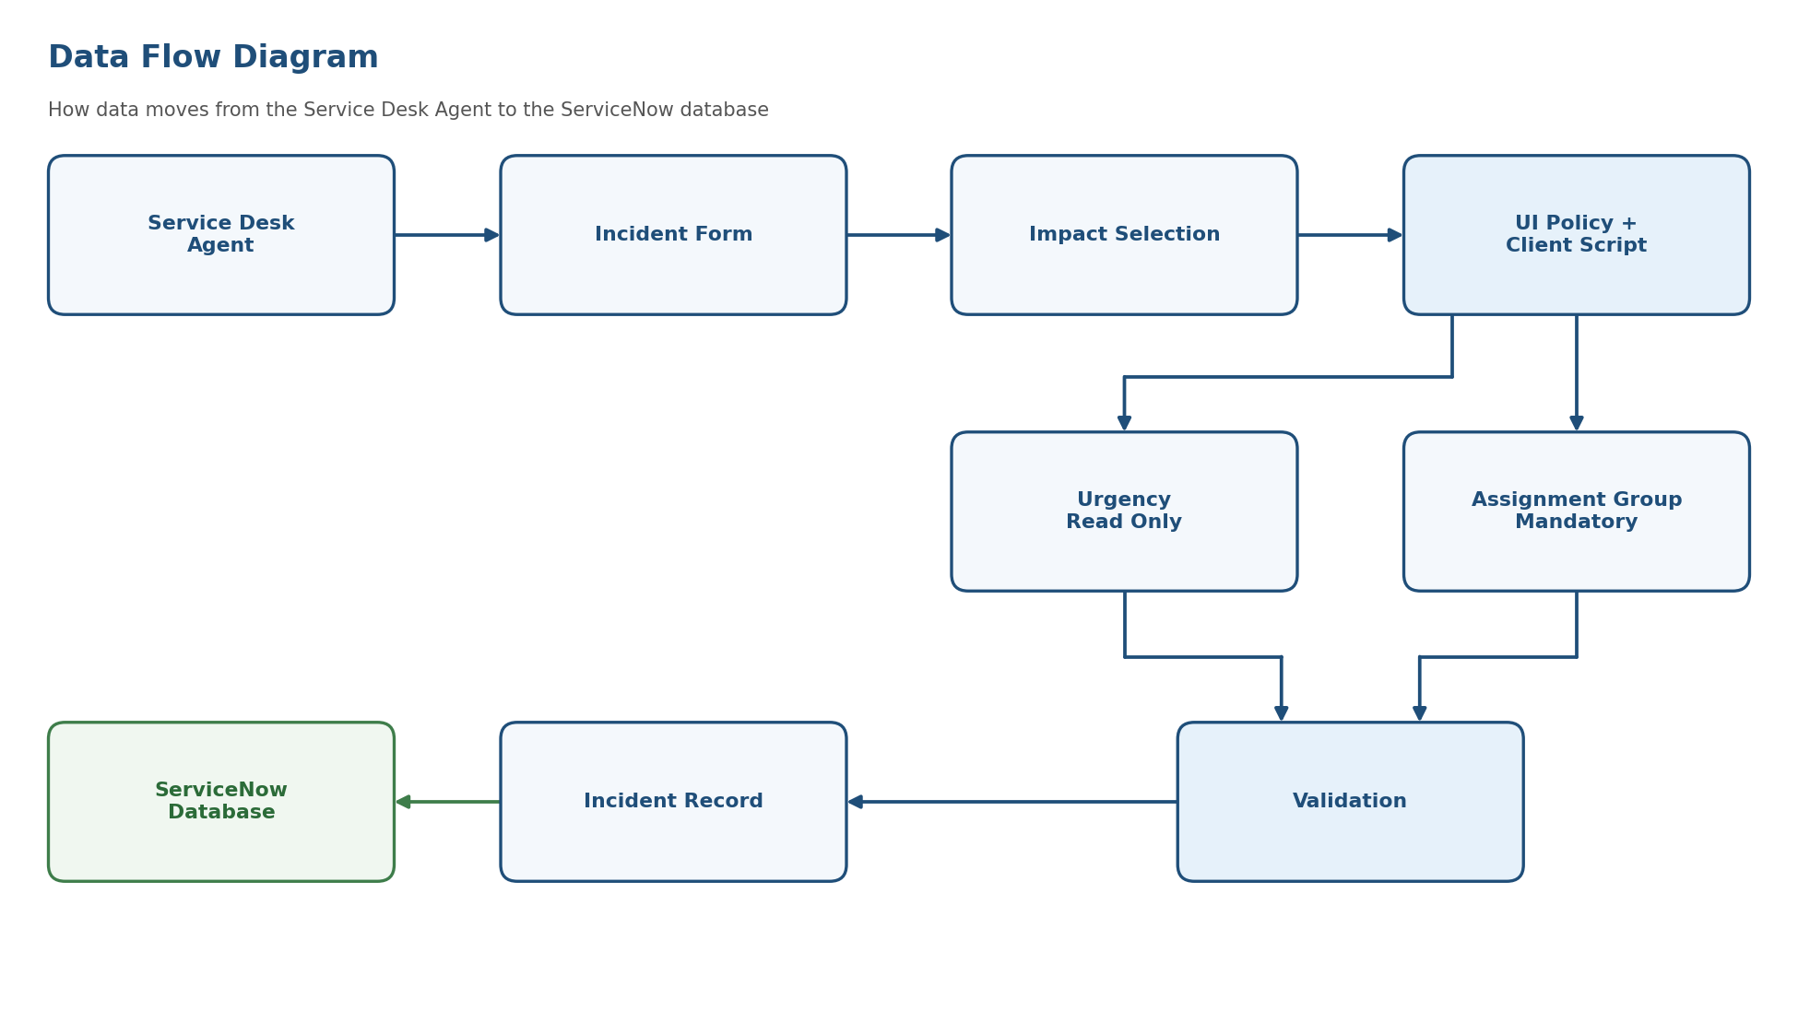
Figure 7 – Data Flow Diagram
4. User Requirements
The requirements are converted into user stories with acceptance criteria, priority and release.
User Type | Functional Requirement / Epic | User Story | Acceptance Criteria | Priority | Release
Service Desk Agent | Incident Form Control | As a Service Desk Agent, I can create an Incident using the Incident form. | Incident form opens and required fields are available. | High | Sprint-1
Service Desk Agent | Impact-Based Control | As a Service Desk Agent, I can select Impact for an Incident. | Impact value can be selected successfully. | High | Sprint-1
Service Desk Agent | Assignment Group Validation | As a Service Desk Agent, I must select an Assignment Group for a High Impact Incident. | Assignment Group becomes mandatory when Impact = High. | High | Sprint-1
Service Desk Agent | Urgency Protection | As a Service Desk Agent, I should not accidentally modify Urgency for a High Impact Incident. | Urgency becomes read-only when Impact = High. | High | Sprint-1
Service Desk Agent | Client Validation | As a Service Desk Agent, I receive a message when required information is missing. | Validation message is displayed before submission. | High | Sprint-1
Service Desk Agent | Submission Control | As a Service Desk Agent, I can submit the Incident when all required information is available. | Incident is submitted successfully when validation passes. | High | Sprint-2
ServiceNow Administrator | Rule Management | As an Administrator, I can configure the UI Policy and Client Script rules. | Rules execute according to the configured conditions. | Medium | Sprint-2
Incident Manager | Incident Quality | As an Incident Manager, I can receive properly completed High Impact Incidents. | High Impact Incidents contain the required Assignment Group information. | Medium | Sprint-2

5. Requirement Analysis
The proposed ServiceNow Incident solution focuses on improving the Incident form by dynamically controlling fields based on the selected Impact value.
When the user selects Impact = High, the system should automatically apply appropriate field controls. The Assignment Group becomes mandatory, while Urgency becomes read-only. Client Scripts are used to validate user actions and UI Policies are used to dynamically control field behavior.
Main Requirements
The system should:
- Detect changes in the Incident form.
- Identify when Impact = High.
- Make Assignment Group mandatory.
- Make Urgency read-only.
- Validate required information before submission.
- Provide clear guidance to the Service Desk Agent.
- Prevent incomplete or inappropriate Incident submission.
- Maintain a consistent Incident-handling process.
6. Functional Requirements
The functional requirements are organized by FR No., Functional Requirement (Epic), and Sub Requirement (Story / Sub-Task).
FR No. | Functional Requirement (Epic) | Sub Requirement (Story / Sub-Task)
FR-1 | Incident Form Control | Display and manage Incident fields dynamically
FR-2 | Impact-Based Field Control | Detect when Impact is changed to High
FR-3 | Assignment Group Validation | Make Assignment Group mandatory when Impact is High
FR-4 | Urgency Protection | Make Urgency read-only when Impact is High
FR-5 | Client-Side Validation | Validate required Incident information before submission
FR-6 | User Guidance | Provide appropriate messages and guidance to the Service Desk Agent
FR-7 | Incident Submission Control | Prevent submission when required information is missing
FR-8 | Dynamic Form Behaviour | Restore normal field behaviour when Impact is changed from High

7. Detailed Functional Requirements
FR-1: Incident Form Control
The system shall provide a ServiceNow Incident form where fields can dynamically change their behaviour based on the Incident context.
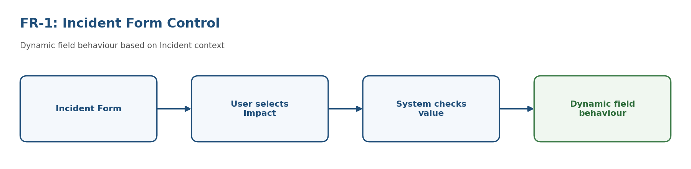
Figure 8 – FR-1: Incident Form Control
FR-2: Impact-Based Field Control
The system shall detect when the user changes the Impact field. If Impact = High, the system should automatically trigger the corresponding UI Policy and Client Script behaviour.
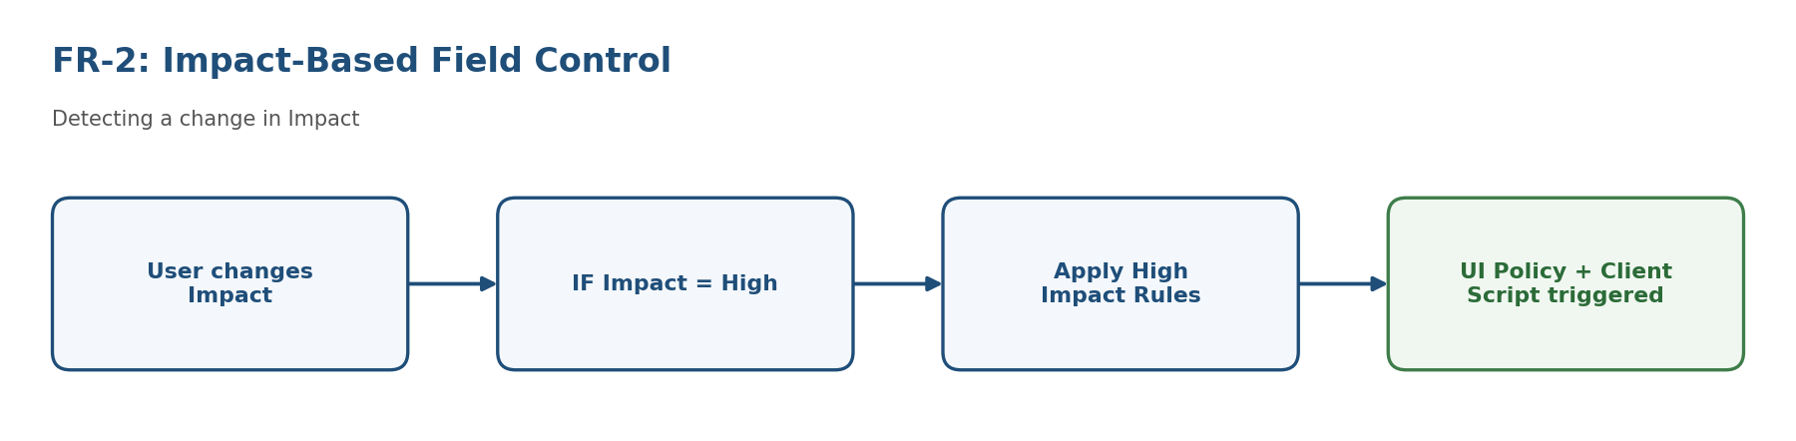
Figure 9 – FR-2: Impact-Based Field Control
FR-3: Assignment Group Validation
When Impact = High, the Assignment Group field shall become mandatory. This helps ensure that high-impact Incidents are assigned to the appropriate support group.
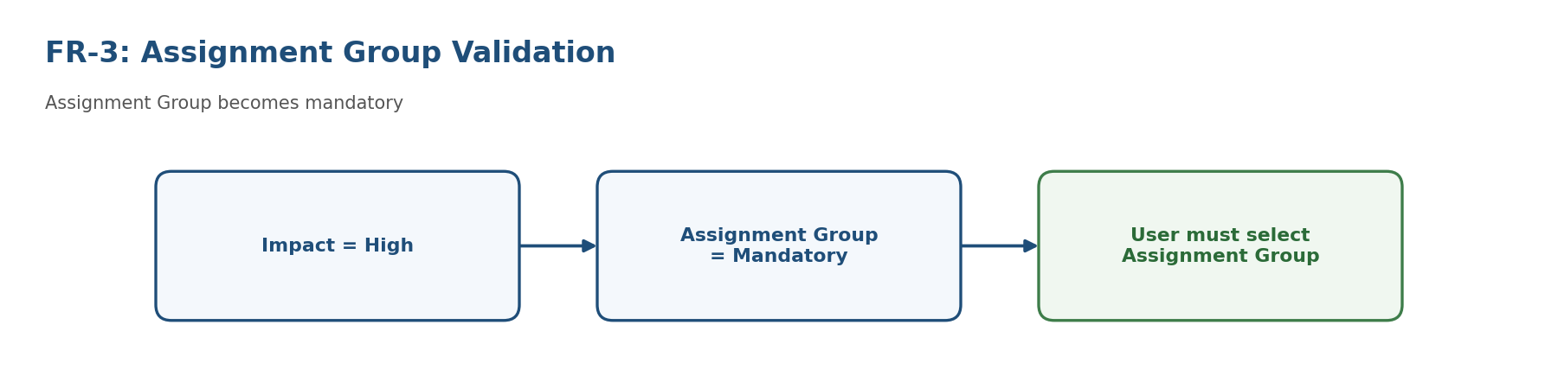
Figure 10 – FR-3: Assignment Group Validation
FR-4: Urgency Protection
When Impact = High, the Urgency field shall become read-only. This prevents unintended changes to the field while handling a high-impact Incident.
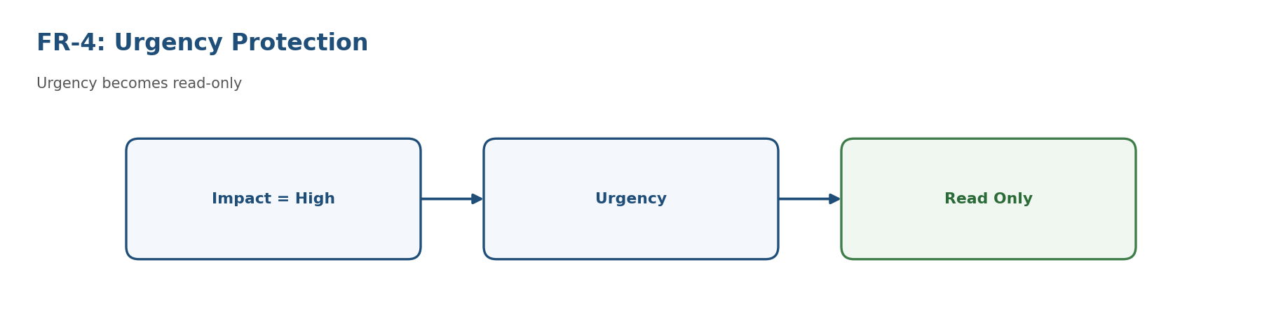
Figure 11 – FR-4: Urgency Protection
FR-5: Client-Side Validation
A Client Script shall validate important Incident information before the record is submitted. The validation checks whether required information is available and provides feedback when information is missing.
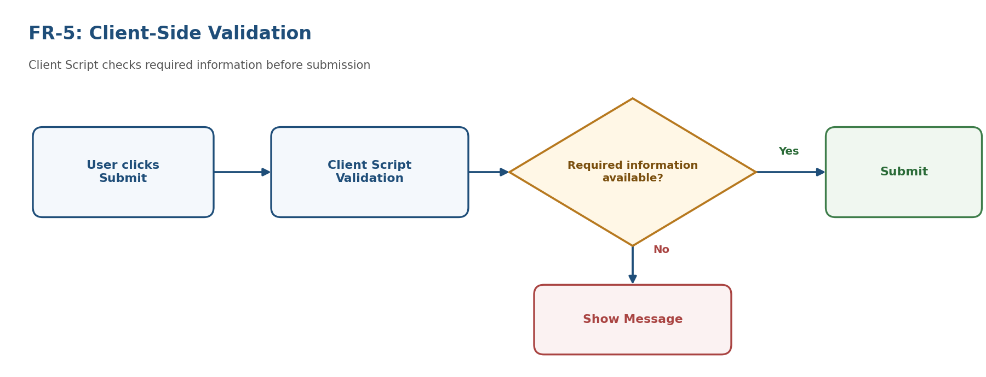
Figure 12 – FR-5: Client-Side Validation
FR-6: User Guidance
The system shall provide clear messages to guide the Service Desk Agent. For example:
"Assignment Group is required for High Impact incidents."
This reduces confusion and helps users complete the Incident correctly.
FR-7: Incident Submission Control
The system shall prevent submission when critical information required for a High Impact Incident has not been provided.
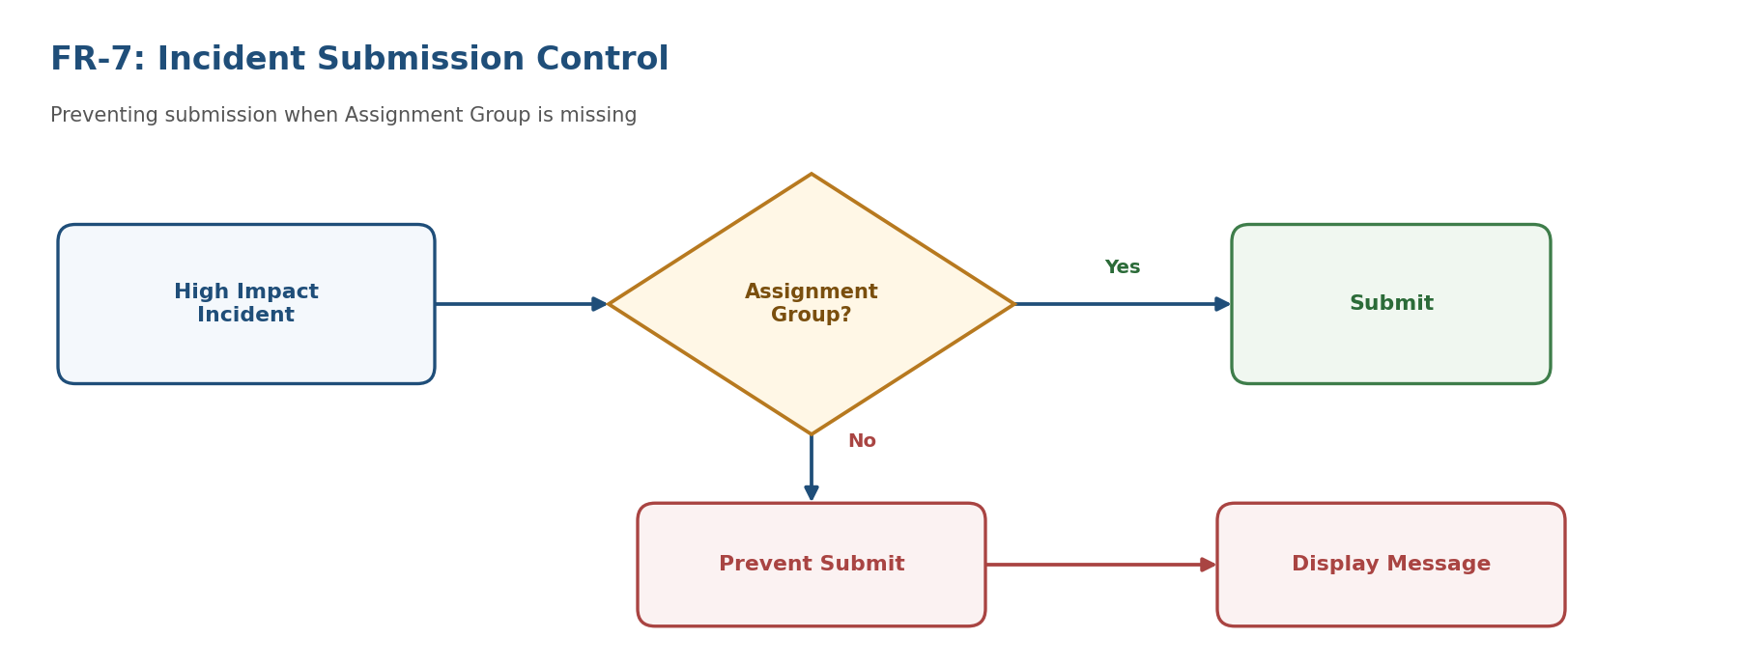
Figure 13 – FR-7: Incident Submission Control
FR-8: Dynamic Form Behaviour
When the Impact value is changed from High to another value, the system shall update the field behaviour accordingly.
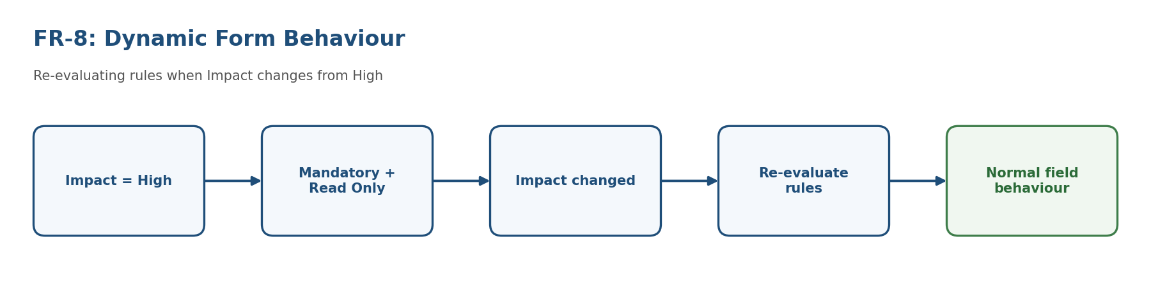
Figure 14 – FR-8: Dynamic Form Behaviour
8. Non-Functional Requirements
The main non-functional requirement categories are Usability, Security, Reliability, Performance, Availability, and Scalability.
NFR No. | Non-Functional Requirement | Description
NFR-1 | Usability | The Incident form should be simple and easy for Service Desk Agents to understand and use.
NFR-2 | Security | Field access and modification should follow the defined Incident access controls.
NFR-3 | Reliability | Client Scripts and UI Policies should consistently apply the defined Incident rules.
NFR-4 | Performance | Dynamic field changes and validations should occur without noticeable delay.
NFR-5 | Availability | The Incident form functionality should be available whenever users access the ServiceNow system.
NFR-6 | Scalability | The solution should support increasing numbers of Incident records and users without changing the core logic.

9. Requirement-to-Implementation Mapping
Requirement | ServiceNow Implementation
Detect Impact change | onChange Client Script
Assignment Group mandatory | UI Policy / UI Policy Action
Urgency read-only | UI Policy / UI Policy Action
Validate before submission | onSubmit Client Script
User guidance | Client Script message / form feedback
Prevent incomplete submission | onSubmit Client Script
Dynamic behaviour | UI Policy + Client Script
Administrative configuration | ServiceNow configuration

10. Requirement Summary
The proposed solution converts manual Incident-form decisions into context-aware system behaviour. The overall requirement is:
When a Service Desk Agent creates or updates an Incident, the ServiceNow system should dynamically respond to the selected Impact value, apply the appropriate field controls, validate critical information, guide the user, and prevent incomplete High Impact Incident submission.

PHASE 3 – PROJECT DESIGN PHASE
Problem – Solution Fit, Proposed Solution & Solution Architecture
Date
Team ID
Project Name | Implement Client Script & UI Policy (Incident)
Maximum Marks

Platform | ServiceNow
Module | Incident Management
Document Sections | Problem – Solution Fit | Proposed Solution | Solution Architecture

Project Objective
To improve the ServiceNow Incident form by controlling field behavior based on conditions, validating important information, and providing a consistent user experience.
Scope
The project focuses on Client Scripts and UI Policies applied to the Incident form. The design covers field visibility, mandatory behavior, read-only behavior, client-side validation, testing and deployment considerations.
1. Problem – Solution Fit Template
Customer Problem Statement
Organizations use ServiceNow Incident records to manage service disruptions and track issue resolution. When the Incident form does not dynamically control fields or validate important information, users may create incomplete or inconsistent records. This can increase manual correction work and affect the quality of Incident management.
Current Challenges
- Important fields may not become mandatory at the appropriate stage.
- Users may forget to provide resolution information before resolving an Incident.
- Fields that are not relevant to a particular condition may remain visible.
- Incomplete input may reach the submission stage without clear user guidance.
- Support teams may spend additional time correcting Incident records.
Business Impact
- Incomplete and inconsistent Incident data.
- Additional effort for Service Desk and support teams.
- Possible delays when important information is missing.
- Reduced consistency in reporting and analytics.
Problem – Solution Fit
Problem | ServiceNow Solution | Expected Benefit
Missing required information | Client Script validation | Checks important values before submission.
Fields should change based on conditions | UI Policy | Controls visibility, mandatory and read-only behavior.
Resolution details may be missed | UI Policy + Client Script | Guides users during Incident resolution.
Manual correction of records | Client-side validation | Reduces common incomplete submissions.

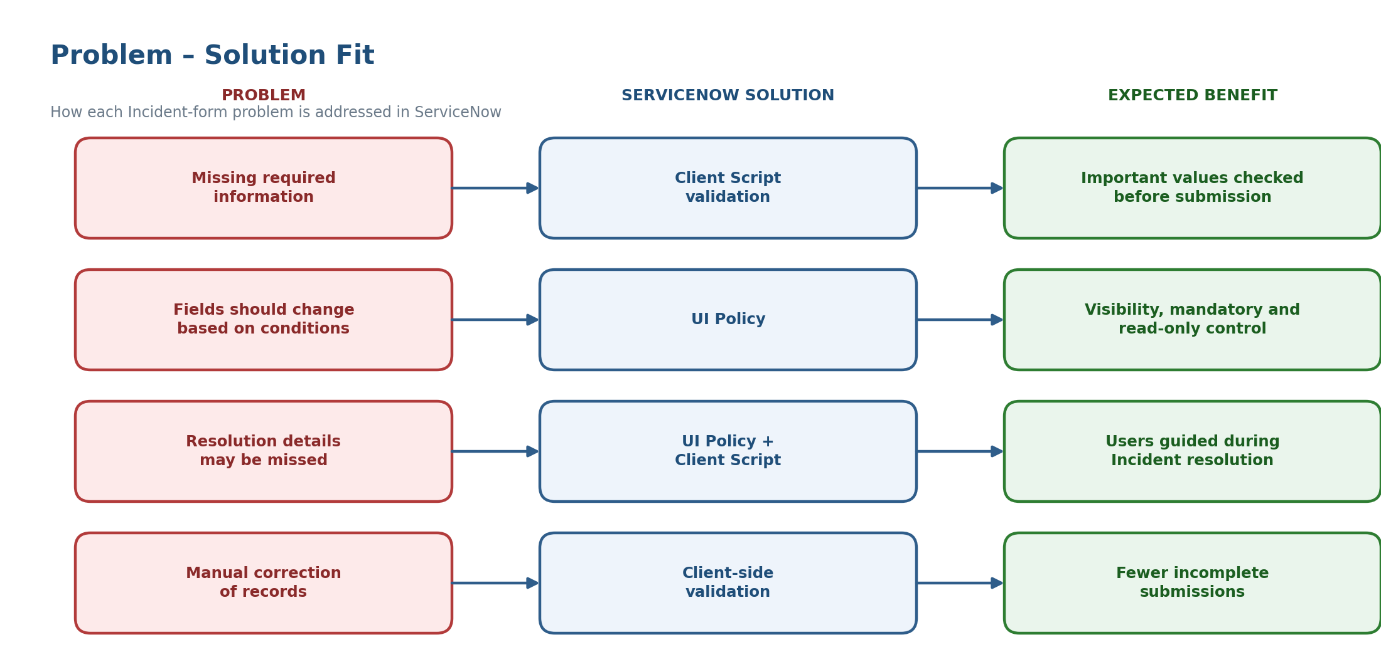
Figure 15 – Problem – Solution Fit
Success Criteria
- Relevant fields respond automatically to configured conditions.
- Required information is clearly identified and validated.
- Users receive clear and understandable messages.
- Incident records become more complete and consistent.
2. Proposed Solution
The proposed solution combines ServiceNow UI Policies and Client Scripts. UI Policies manage field behavior according to conditions, while Client Scripts provide client-side validation and dynamic actions. This approach keeps the Incident form structured and easier for users to complete.
Process Flow
Step 1 | Step 2 | Step 3 | Step 4 | Step 5
Incident Form – User opens or updates an Incident. | UI Policy – Controls visibility, mandatory and read-only behavior. | Client Script – Runs dynamic logic and validation. | Validation – Checks important information before submission. | Submission – Validated Incident is submitted.

UI Policy Design
Condition | Field / Control | Action | Purpose
State = Resolved | Resolution code | Visible + Mandatory | Ensure resolution category is captured.
State = Resolved | Resolution notes | Visible + Mandatory | Capture the resolution details.
State = Closed | Relevant fields | Read-only where required | Avoid unnecessary post-closure changes.
Category selected | Dependent fields | Show / Hide | Display relevant information.

Client Script Design
Script Type | Trigger | Purpose
onLoad | Incident form opens | Apply initial form behavior and guidance.
onChange | A configured field changes | React to state, category or other changes.
onSubmit | User submits the form | Validate important information before submission.

User Process
The user opens an Incident, enters the required information, and updates the record. UI Policies respond to configured conditions, while Client Scripts provide validation or messages when required. After the configured checks are satisfied, the Incident can be submitted.
Expected Benefits
- Improved Incident data quality and consistency.
- Reduced incomplete submissions and manual correction.
- Clearer and more guided form experience.
- More consistent resolution information.
- Improved reliability of Incident reporting.
3. Solution Architecture
The solution is centered on the ServiceNow Incident form. The user interacts with the form, UI Policies control field behavior, and Client Scripts provide client-side logic and validation. The validated Incident is then stored in the ServiceNow Incident table.
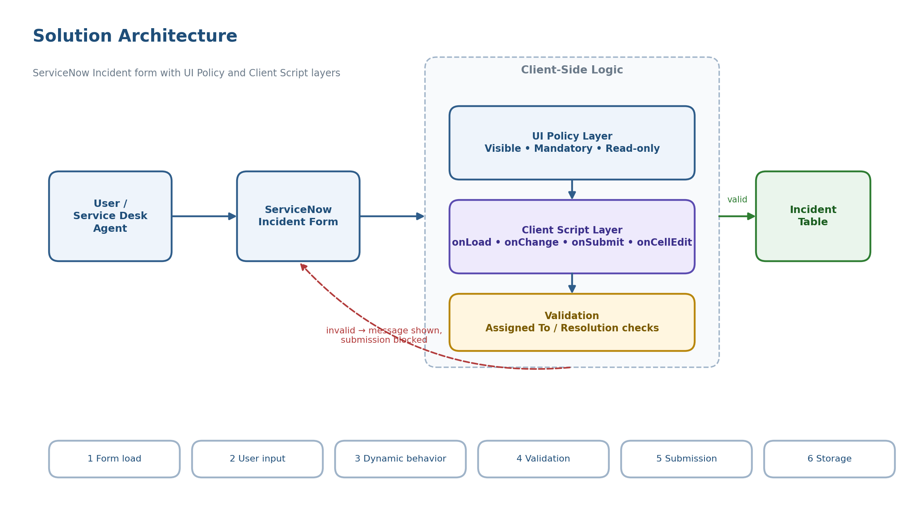
Figure 16 – Solution Architecture Diagram
Logical Architecture
Component | Responsibility
User / Service Desk Agent | Creates, updates and resolves Incident records.
ServiceNow Incident Form | Displays fields and collects Incident information.
UI Policy Layer | Controls visibility, mandatory status and read-only behavior.
Client Script Layer | Runs onLoad, onChange and onSubmit client-side logic.
Validation | Checks important conditions before submission.
Incident Table | Stores the final Incident record.

Detailed Working
Step | Stage | Process
1 | Form Load | The Incident form opens and applicable UI Policies and onLoad Client Scripts establish the initial behavior.
2 | User Input | The user enters Incident information such as description, category, assignment and state.
3 | Dynamic Behavior | When configured fields change, UI Policies and onChange Client Scripts respond accordingly.
4 | Resolution | When the Incident reaches the configured resolution state, resolution-related fields can become visible and mandatory.
5 | Submission | An onSubmit Client Script validates important information before the record is submitted.
6 | Storage | After successful validation, the Incident record is stored in the ServiceNow Incident table.

4. Implementation & Testing
Suggested UI Policy Configuration
Property | Configuration
Name | Incident – Resolution Information Required
Table | Incident
Condition | State is Resolved
Actions | Make Resolution code and Resolution notes visible and mandatory as required by the implementation.

Suggested Client Script Configuration
Type: onSubmit. The script checks important resolution information when the Incident is in the Resolved state. If required information is missing, it displays a clear message and prevents submission until the user completes the required fields.
Testing Plan
Test Case | Expected Result
Create a normal Incident | Incident can be entered and submitted normally.
Change state to Resolved | Configured UI Policy behavior is applied.
Submit without required resolution information | Validation message appears and submission is stopped.
Enter all required resolution information | Submission is allowed.
Change a configured category/state | Relevant dynamic behavior occurs.
Move Incident to Closed | Configured read-only behavior is applied.

Deployment Considerations
- Use clear names and precise conditions for Client Scripts and UI Policies.
- Test the configuration in a development or test instance before production.
- Verify the behavior with the intended ServiceNow user roles.
- Document each script and policy for future maintenance.
- Prefer a UI Policy when the requirement can be handled without custom scripting.
5. Conclusion
The Implement Client Script & UI Policy (Incident) solution provides a structured approach to improving the ServiceNow Incident form. UI Policies manage condition-based field behavior, while Client Scripts provide dynamic actions and client-side validation. Together, they help users provide the required information and improve the consistency of Incident records.
Key Terms
Term | Simple Meaning
Incident | A record used to track a service interruption or issue.
UI Policy | A rule that changes field behavior based on a condition.
Client Script | Client-side JavaScript logic used on a ServiceNow form.
onLoad | Runs when the form opens.
onChange | Runs when a field value changes.
onSubmit | Runs when the user submits the form.
Mandatory | A field must contain a value before submission.
Read-only | A field cannot be edited in the configured state.

PHASE 4 – PROJECT PLANNING PHASE
Planning Logic, Implementation & Testing Plan
Date
Team ID
Project Name | Implement Client Script & UI Policy (Incident)
Maximum Marks

1. Project Planning Template
The project focuses on improving Incident data quality and user guidance by applying Client Scripts and UI Policies on the Incident form.
Project Planning Summary
Item | Planned Details
Platform | ServiceNow
Module | Incident Management
Project Type | Configuration / Client-side scripting
Main Features | UI Policy, UI Policy Actions, Client Scripts, Form Validation
Business Goal | Improve Incident data accuracy, consistency and user guidance
Main Trigger | Impact = High
Expected Outcome | Controlled Incident form with clear field behavior and validation

Brief Content
- Incident records need complete and accurate information for effective triage, routing and resolution.
- Manual checking can lead to incomplete or incorrect information.
- UI Policies control field behavior such as mandatory and read-only states.
- Client Scripts handle dynamic updates, validation and user guidance.
Project Objectives
- Make selected fields mandatory when a defined condition is true.
- Control field behavior automatically.
- Set Urgency automatically when Impact becomes High.
- Prevent saving when required Assigned To information is missing.
- Prevent direct State changes through list editing.
ServiceNow Skills
- Incident Management; UI Policy; UI Policy Actions.
- Client Scripts: onChange, onSubmit and onCellEdit.
- Form Validation.
2. Project Planning Template – Implementation & Testing
Implementation converts the project rules into UI Policy Actions and Client Scripts, followed by functional testing.
Implementation
Step | Configuration | Expected Result
1 | Create UI Policy: High Impact Control; Table = Incident; Condition = Impact is High; Active = true; Reverse if false = true. | Policy activates for High Impact and reverses when the condition is false.
2 | UI Policy Action: Assignment Group -> Mandatory. | Assignment Group becomes mandatory for High Impact.
3 | UI Policy Action: Urgency -> Read-only; Visible unchanged. | Urgency remains visible but cannot be edited for High Impact.
4 | onChange Client Script on Impact; when Impact becomes High, set Urgency to High. | Urgency is automatically set to High.
5 | onSubmit Client Script; when Impact is High and Assigned To is empty, show error and return false. | Save is blocked until Assigned To is provided.
6 | onCellEdit Client Script on State; alert user and return callback(false). | Direct State list editing is blocked.

Implementation in Brief
- UI Policy: handles High Impact field conditions.
- Assignment Group: becomes mandatory.
- Urgency: becomes read-only.
- onChange: sets Urgency to High.
- onSubmit: validates Assigned To.
- onCellEdit: blocks direct State list edits.
Testing
Test Case | Action | Expected Result
Mandatory Enforcement | Impact = High; Assigned To empty; Submit. | Save is blocked and an Assigned To error appears.
Successful Save | Impact = High; fill Assigned To; Submit. | Incident saves successfully.
Reverse Condition | Change Impact from High to Medium. | Assigned To is no longer mandatory and Urgency becomes editable.
List Edit Blocking | Edit State directly from Incident list. | Alert appears and State remains unchanged.
Form-Based Update | Open Incident; change State; Update. | State change saves successfully through the form.

Testing in Brief
- Test both valid and invalid conditions.
- Verify High and non-High Impact behavior.
- Confirm error messages and blocked actions.
- Confirm valid changes through the Incident form still work.
3. Planning Logic
The Incident follows a simple sequence: condition -> UI control -> automation -> validation -> save or block.
Stage | Logic | Result
Start | Create or open an Incident. | User begins entering Incident details.
Condition | Set Impact = High. | High Impact rules are triggered.
UI Control | Assignment Group = Mandatory; Urgency = Read-only. | Field behavior is controlled automatically.
Automation | onChange sets Urgency = High. | Urgency is populated automatically.
Submit | User clicks Submit. | onSubmit validation runs.
Decision | Check Assigned To. | Valid -> save; missing -> show error and block save.
List Edit | User tries to change State directly in the list. | onCellEdit blocks the direct change.

Planning Logic in Brief
- Impact = High is the main trigger.
- UI Policy makes Assignment Group mandatory and Urgency read-only.
- onChange automatically sets Urgency to High.
- onSubmit checks whether Assigned To is present.
- Valid information allows the Incident to save; missing information blocks the save.
Planning Logic – Flowchart
The flowchart represents the same Incident planning logic described above.
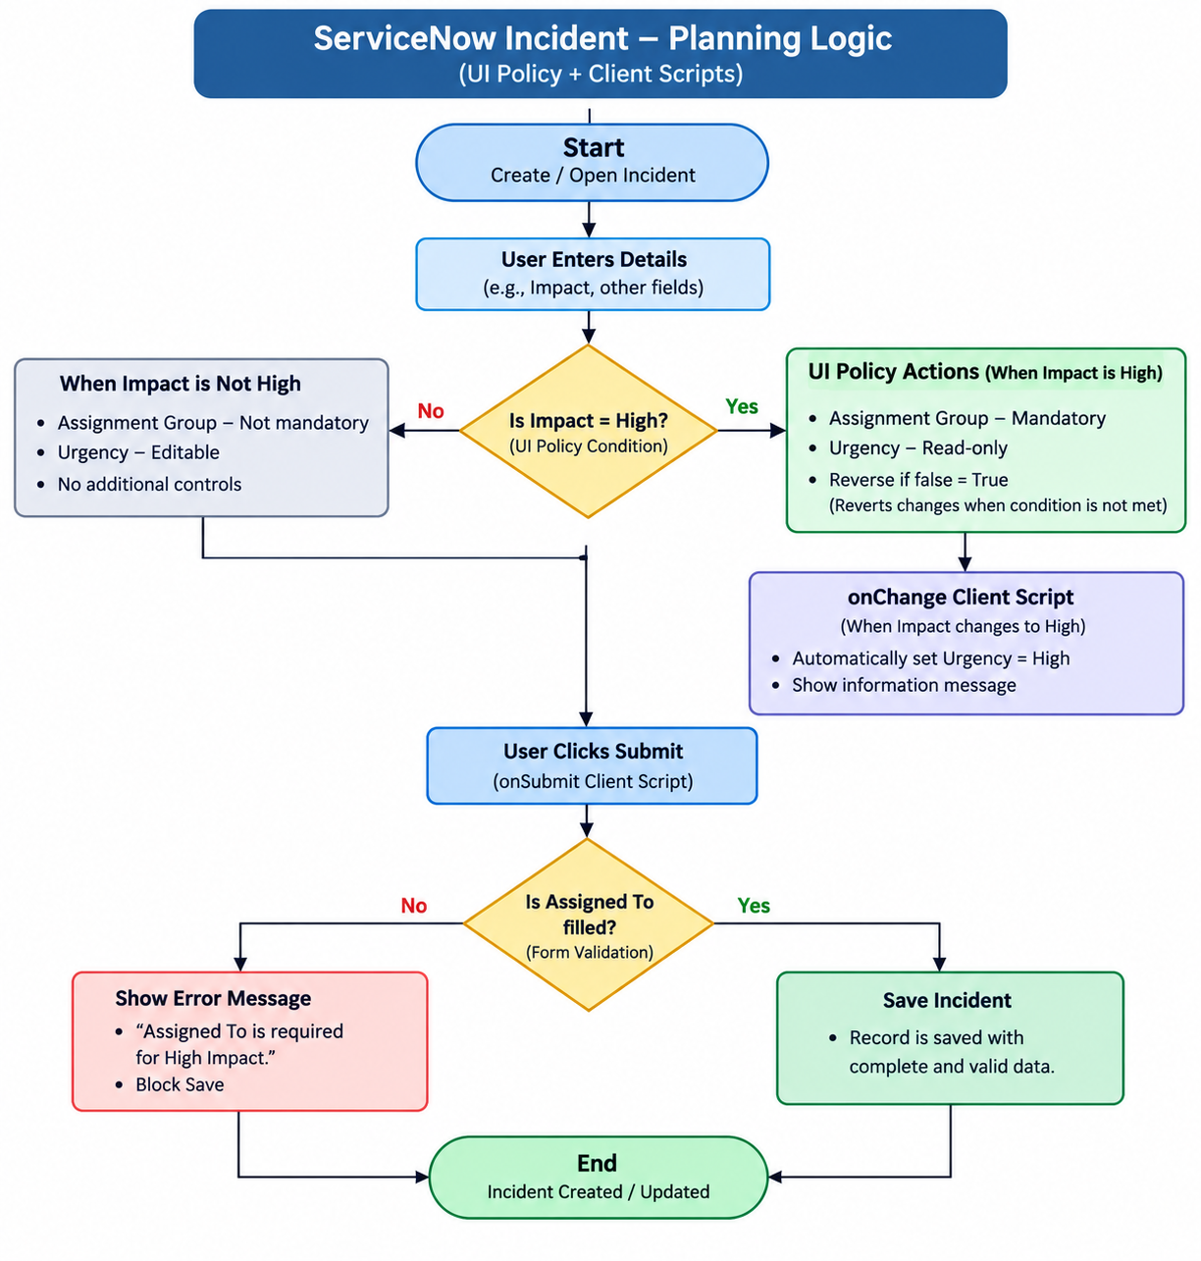
Figure 17 – Planning Logic Flowchart
Flowchart Explanation in Brief
- Create or open an Incident and enter the required details.
- When Impact is High, Assignment Group becomes mandatory and Urgency becomes read-only.
- The onChange Client Script sets Urgency to High.
- When Submit is clicked, the onSubmit Client Script checks Assigned To.
- Missing Assigned To -> show an error and block save. Filled Assigned To -> save the Incident.
- Direct State editing from the list is blocked by the onCellEdit Client Script.
4. Remaining Planning Details
Roles and Responsibilities
- ServiceNow Admin / Developer: Configure UI Policies and Client Scripts and perform technical testing.
- Business / Process Owner: Confirm business rules and expected Incident behavior.
- Tester: Execute test cases and record actual results.
- Reviewer / Approver: Review the implementation and approve deployment.
Deliverables
- High Impact Control UI Policy and its UI Policy Actions.
- onChange Client Script for automatic Urgency.
- onSubmit Client Script for Assigned To validation.
- onCellEdit Client Script for State list-edit blocking.
- Testing evidence and final project documentation.
Timeline
Requirement Review -> UI Policy -> Client Scripts -> Testing -> Review -> Deployment
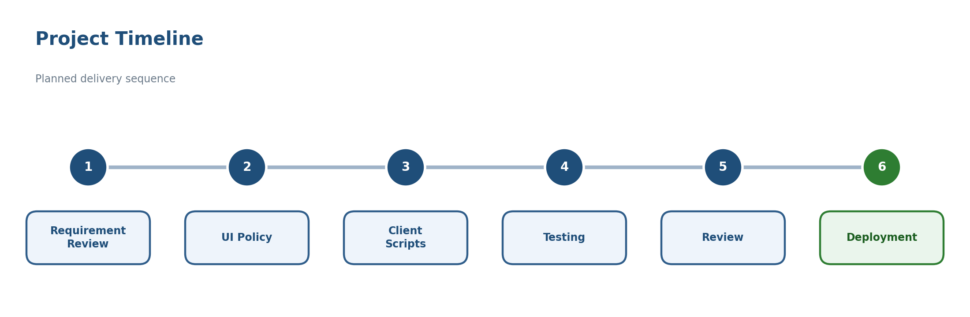
Figure 18 – Project Timeline
Risks and Mitigation
Risk | Mitigation
Incorrect condition | Test both true and false conditions.
Conflicting scripts | Review existing Client Scripts before adding new logic.
Incomplete testing | Execute all defined test cases.
List-edit restriction misunderstood | Clearly explain that State changes should be made through the Incident form.

Acceptance Criteria
- Impact = High triggers the required UI Policy behavior.
- Assignment Group becomes mandatory and Urgency becomes read-only.
- Urgency is automatically set to High.
- High Impact with empty Assigned To prevents save.
- Direct State editing from the list is blocked.
- State changes through the Incident form can be saved.
- Changing Impact away from High reverses the relevant UI behavior.
- All test cases produce the expected results.
Conclusion
UI Policies and Client Scripts work together to control Incident fields, automate updates, validate required information and guide users toward the correct workflow.

PHASE 5 – PROJECT DEVELOPMENT & TESTING PHASE
Implement Client Script & UI Policy (Incident)
Date
Team ID
Project Name | Implement Client Script & UI Policy (Incident)
Maximum Marks

1. Development
The project was developed in ServiceNow Incident Management using UI Policies and Client Scripts. The objective was to automate field behavior, enforce business rules, validate Incident records, and improve overall data quality.
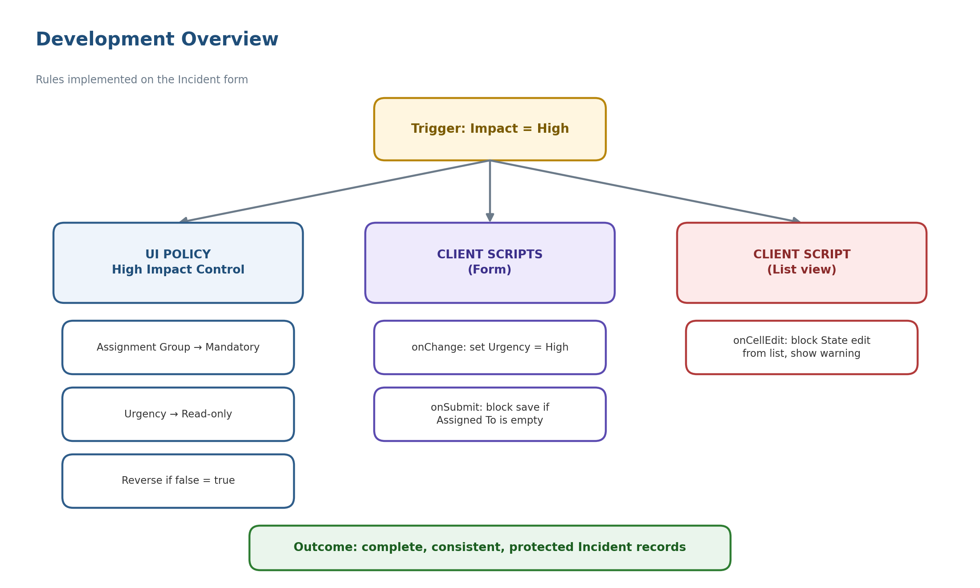
Figure 19 – Development Overview
Development Activity 1 – Create UI Policy
UI Policy Name | High Impact Control
Purpose | To automatically apply field controls when Impact is set to High.
Configuration | Table: Incident  Condition: Impact = High  Active: True  Reverse if False: True
Outcome | UI Policy triggers automatically. Rules are removed when Impact changes from High.

Development Activity 2 – Configure UI Policy Actions
UI Policy Action | Purpose | Result
Assignment Group Mandatory | Ensure all High Impact Incidents contain Assignment Group information. | Users cannot leave Assignment Group blank.
Urgency Read Only | Prevent unauthorized changes to Urgency. | Urgency remains protected once automatically set.

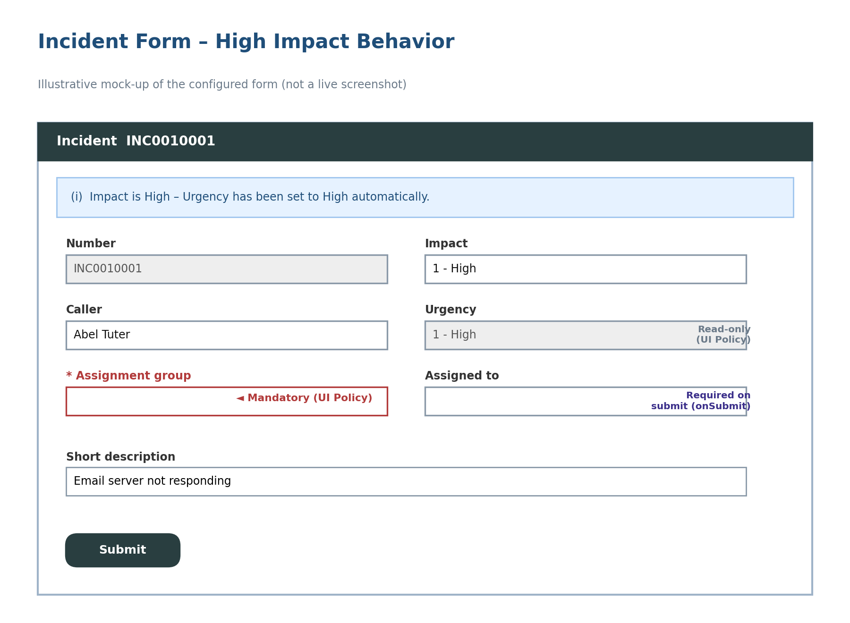
Figure 20 – Incident Form with High Impact Controls (illustrative mock-up)
Development Activity 3 – Develop onChange Client Script
Trigger | Impact field changes.
Functionality | Detect Impact = High. Automatically set Urgency = High. Display informational message.
Outcome | Consistent prioritization of High Impact Incidents.

Development Activity 4 – Develop onSubmit Client Script
Trigger | Record Submission
Functionality | Verify Assigned To field. Prevent submission when Impact is High and Assigned To is empty.
Outcome | Incomplete Incident records cannot be saved.

Development Activity 5 – Develop onCellEdit Client Script
Trigger | List View State Update
Functionality | Detect State modification from list view. Block update. Display warning message.
Outcome | Sensitive fields remain protected.

2. Performance Testing
The objective is to verify that UI Policies and Client Scripts execute efficiently without affecting system performance.
Test Scenario | Action | Expected Result | Actual Result | Status
Test Scenario 1 | Set Impact = High. | Assignment Group becomes mandatory. Urgency becomes read-only. | Both actions executed immediately. | Passed
Test Scenario 2 | Change Impact to High. | Urgency automatically changes to High. | Urgency updated instantly. | Passed
Test Scenario 3 | Submit High Impact Incident without Assigned To. | Submission blocked immediately. | Error message displayed and submission prevented. | Passed

Performance Testing Summary
Test Area | Result
UI Policy Performance | Passed
onChange Script Performance | Passed
onSubmit Validation Performance | Passed
Form Response Time | Passed
Overall System Performance | Passed

3. User Acceptance Testing (UAT)
The objective is to confirm that the implemented solution meets user requirements and business expectations.
UAT Case | Requirement | User Feedback | Status
UAT Case 1 | Assignment Group mandatory for High Impact Incidents. | Requirement achieved successfully. | Accepted
UAT Case 2 | Urgency automatically set to High. | Functionality works correctly. | Accepted
UAT Case 3 | Prevent save when Assigned To is empty. | Validation works as expected. | Accepted
UAT Case 4 | Reverse UI Policy actions when Impact changes. | Rules removed correctly. | Accepted
UAT Case 5 | Prevent State updates through list editing. | Restriction works successfully. | Accepted

UAT Summary
Requirement | Status
High Impact Control | Accepted
Assignment Group Mandatory | Accepted
Urgency Read Only | Accepted
Auto Urgency Update | Accepted
Submit Validation | Accepted
State Protection | Accepted

Final UAT Result
Total Test Cases | 5
Accepted | 5
Rejected | 0
User Acceptance Status | Successfully Approved

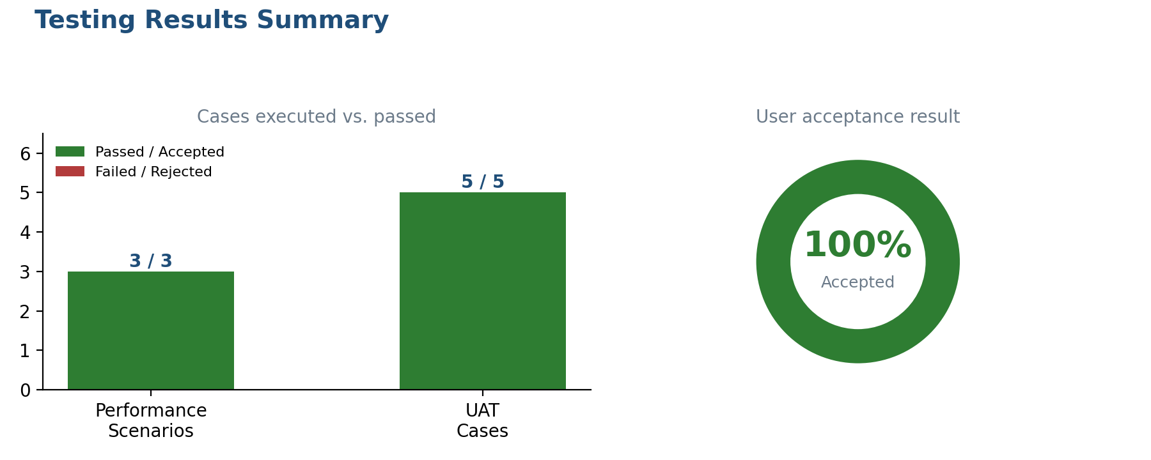
Figure 21 – Testing Results Summary

PHASE 6 – PROJECT DOCUMENTATION
Project Report
Date
Team ID
Project Name | Implement Client Script & UI Policy (Incident)
Maximum Marks

Platform | ServiceNow
Module | Incident Management
Main Focus | Client Scripts, UI Policies, Incident form behavior and validation

1. Introduction
1.1 Project Overview
This project focuses on implementing Client Scripts and UI Policies in ServiceNow Incident Management. The solution is designed to make the Incident form more controlled, understandable and consistent by changing field behavior based on conditions and validating important information on the client side.
The project covers the complete design flow from identifying the Incident-form problem through requirements, solution design, implementation approach and expected results.
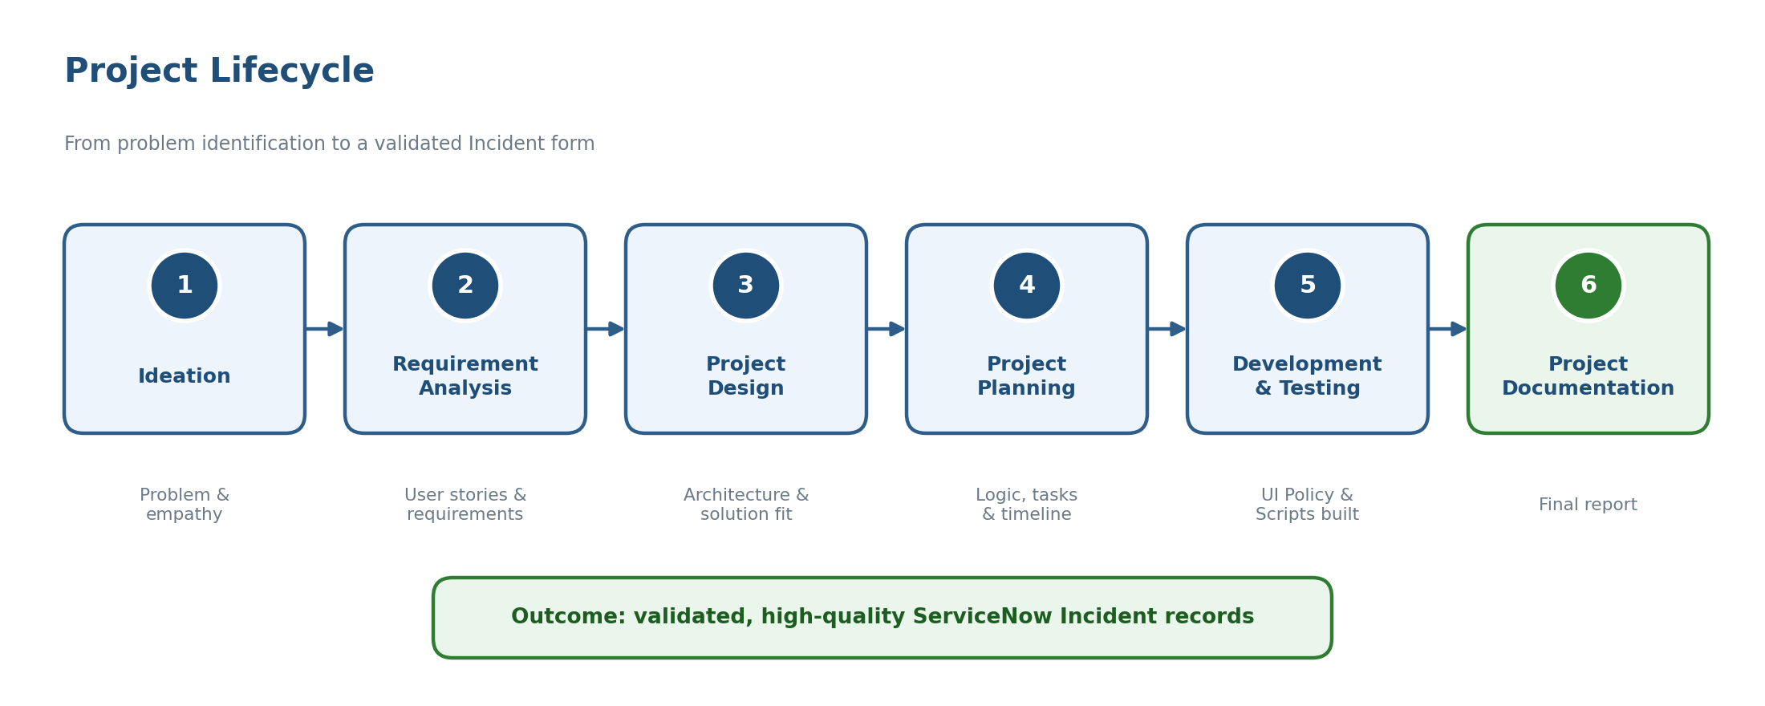
Figure 22 – Project Lifecycle
1.2 Purpose
The purpose is to guide Service Desk users while creating and updating Incident records. UI Policies are used for condition-based field behavior such as visibility, mandatory status and read-only behavior. Client Scripts are used for dynamic client-side logic and validation.
Objectives
- Improve completeness and consistency of Incident records.
- Reduce incorrect or incomplete submissions.
- Show users only the information relevant to the current Incident condition.
- Provide clear validation before an Incident is submitted.
2. Ideation Phase
2.1 Problem Statement
Incident forms can become difficult to use when fields are not dynamically controlled. Users may leave important information incomplete or enter data that is not relevant to the current Incident state. This can create additional correction work and reduce the quality of Incident records.
2.2 Empathy Map Canvas
The main user considered in the project is the Service Desk Agent. The agent needs a form that clearly indicates what information is required and provides guidance when Incident conditions change.
User Need | Observed Challenge
Know which fields are required | Important information may be missed.
See relevant fields | Unnecessary fields may remain visible.
Receive clear validation | Submission may fail without understandable guidance.
Complete resolution details | Resolution information may be incomplete.

2.3 Brainstorming
- Use UI Policies for condition-based field behavior.
- Use Client Scripts for onLoad, onChange and onSubmit logic.
- Validate important Incident information before submission.
- Apply resolution-related rules when the Incident reaches the Resolved state.
3. Requirement Analysis
3.1 Customer Journey Map
Open Incident → Enter Incident Details → Form Rules Respond → Validate Information → Submit Incident
The journey begins when a Service Desk Agent opens or creates an Incident. As field values change, configured UI Policies and Client Scripts respond. Before submission, validation checks the required information.
3.2 Solution Requirement
Requirement | Expected Behavior
Dynamic field control | Fields change visibility, mandatory status or read-only behavior according to conditions.
Client-side validation | Important values are checked before the form is submitted.
Resolution control | Resolution information can become visible and mandatory when the Incident is Resolved.
Consistent user guidance | Users receive clear feedback when required information is missing.

3.3 Data Flow Diagram
User / Agent → Incident Form → UI Policy & Client Script Logic → Validation → Incident Submission → Incident Record
Figure 23 – Data Flow Diagram
3.4 Technology Stack
Technology / Component | Purpose
ServiceNow | Platform used for Incident Management and configuration.
Incident Management | Application area where the form behavior is implemented.
UI Policy | Controls field visibility, mandatory and read-only behavior based on conditions.
Client Script | Provides client-side JavaScript logic and validation.

4. Project Design
4.1 Problem Solution Fit
Problem | Solution
Incomplete Incident information | Client Script validation before submission.
Fields need condition-based behavior | UI Policy controls visibility, mandatory and read-only status.
Resolution details may be missed | UI Policy and Client Script guide resolution information.

4.2 Proposed Solution
The proposed solution combines UI Policies and Client Scripts. UI Policies handle predictable condition-based field behavior, while Client Scripts provide dynamic actions and client-side validation. This combination creates a more guided Incident form without changing the underlying Incident-management process.
4.3 Solution Architecture
Layer | Responsibility
User / Agent | Creates, updates and resolves Incidents.
Incident Form | Collects Incident information.
UI Policy Layer | Controls field behavior according to conditions.
Client Script Layer | Runs client-side logic and validation.
Incident Record | Stores the validated Incident information.

Implementation Flow: Incident Form → Condition Checked → UI Policy Applies → Client Script Executes When Required → Validation → Successful Submission
Figure 24 – Solution Architecture
5. Results
5.1 Expected Output
After implementation, the Incident form should respond to configured conditions and provide a more consistent experience for Service Desk users.
Output | Expected Result
Incident form | Relevant fields respond to configured conditions.
Resolved state | Configured resolution fields become visible and/or mandatory as required.
Validation | Missing required information is identified before submission.
Submission | Valid Incident information can be submitted successfully.

Figure 25 – Incident Form with High Impact Controls (illustrative mock-up)
5.2 Testing
- Create a normal Incident and verify the form works as expected.
- Change the Incident state and verify the configured UI Policy behavior.
- Attempt submission with missing required information and verify validation.
- Enter the required information and verify successful submission.
- Verify configured read-only behavior in the appropriate state.
5.3 Benefits
- Improves Incident data quality and consistency.
- Reduces incomplete submissions and manual correction.
- Provides clearer guidance to Service Desk users.
- Supports more consistent Incident resolution information.
6. Conclusion
The Implement Client Script & UI Policy (Incident) project provides a structured way to improve the ServiceNow Incident form. The project begins with the identification of common form-related problems, defines the user and system requirements, and then designs a solution using UI Policies and Client Scripts.
UI Policies provide condition-based control over field behavior, while Client Scripts support dynamic client-side logic and validation. Together, they help users enter the required information and create more consistent Incident records.
The overall project flow is: Introduction → Ideation → Requirement Analysis → Project Design → Implementation → Results → Conclusion.
The proposed design can be tested in a ServiceNow development or test environment before deployment. Actual screenshots and measured performance results should be added after the configured solution is executed in the target ServiceNow instance.
Future Enhancement
- Extend the rules to additional Incident fields and business conditions.
- Add more validation rules where required.
- Expand automated testing for different Incident states and user roles.
- Monitor Incident data quality and refine the rules as requirements evolve.

